WEEK 5 PROJECT REPORT
Model Training and Evaluation
Exploring Customer Feedback and Product Sentiment
Internship | Data Science with Python Analyst Internship
Domain | Beauty & Wellness
Week | Week 5
Submission date | 30 October 2026 (as recorded in source README)
Task | Five-class customer rating prediction
This report documents the dataset preparation, TF-IDF feature extraction, model training, evaluation metrics, confusion matrix, saved artifacts, limitations, and recommended next steps.

Report contents
1. Executive Summary | 2. Business Problem | 3. Dataset and Preparation | 4. TF-IDF Text Representation | 5. Multinomial Naive Bayes | 6. Logistic Regression | 7. Evaluation and Comparison | 8. Confusion Matrix | 9. Outputs and Reproducibility | 10. Limitations and Improvements | 11. Conclusion and Checklist

1. Executive Summary

Project purpose
Week 5 covers model training and evaluation for the Data Science with Python Analyst Internship project, “Exploring Customer Feedback and Product Sentiment,” in the Beauty & Wellness domain. The goal of this stage is to train machine-learning models that predict a customer’s star rating from the written review text, compare their performance on held-out data, and save the best-performing model and supporting outputs. This phase builds on the cleaned review dataset and the descriptive work completed during earlier weeks.

Work completed
The submitted Python script loads the cleaned review CSV, checks that the `text` and `rating` columns exist, removes unusable rows, restricts ratings to values from 1 through 5, and splits the records into training and testing sets. It creates pipelines that combine TF-IDF text vectorization with two classifiers: Multinomial Naive Bayes and Logistic Regression. Both models are trained and evaluated using accuracy, macro precision, macro recall, and macro F1-score. The script also writes detailed classification reports, stores test predictions, saves a comparison table, serializes the model selected by macro F1-score, and produces a confusion-matrix image.

Headline results
The supplied terminal output reports 693,443 usable records, with 554,754 records for training and 138,689 for testing. Logistic Regression achieved accuracy 0.726518, macro precision 0.511134, macro recall 0.437938, and macro F1-score 0.441833. Multinomial Naive Bayes achieved accuracy 0.707655, macro precision 0.520400, macro recall 0.378670, and macro F1-score 0.372669. Logistic Regression was selected because its macro F1-score was higher. The result is a baseline rather than evidence that rating prediction is solved; class imbalance and the remaining errors are important limitations.

Validation and warning
The confusion-matrix values in the supplied image sum to 138,689, matching the test-set size shown in the terminal. An older report draft mistakenly referred to roughly 13,869 test records and incorrectly flagged the matrix as inconsistent. This revised report uses the current screenshots and script as the basis for the documented results. Logistic Regression did produce a convergence warning because the configured maximum of 300 iterations was reached, so the model’s optimization settings can be improved in a later iteration.

2. Project Background and Business Problem

Why review-rating prediction matters
Written reviews contain information about how customers describe product experiences. In the Beauty & Wellness domain, the text may mention texture, scent, packaging, value, delivery, ease of use, perceived effectiveness, or dissatisfaction. A rating from one to five stars provides a compact label, while the review text is the input that a text-classification model attempts to use to predict that label. Learning the relationship between text and rating can help demonstrate a practical text-mining workflow and identify how well a simple model can recover ratings from written feedback.

Problem statement
The technical problem is a five-class text-classification task: given a review string, predict one of the rating labels 1, 2, 3, 4, or 5. The model is not directly predicting product quality or objective satisfaction. It is learning statistical patterns from the text and labels available in the dataset. Its predictions should therefore be interpreted as estimates of the rating associated with a review, not as verified facts about a product or customer.

Why two models are compared
Multinomial Naive Bayes is a common baseline for text classification because it is computationally efficient and works with non-negative text features. Logistic Regression is a linear classifier that can learn weights for TF-IDF features and often performs well on sparse text representations. Comparing the two gives a practical benchmark: it shows whether a more flexible linear decision boundary improves class-wise performance over the Naive Bayes baseline in this dataset.

Business and evaluation boundaries
The project is educational and exploratory. It does not establish that these models should be used to automatically moderate reviews, make product decisions, or replace human interpretation. The rating distribution is uneven, and the model may be much better at identifying the majority five-star class than minority classes. Results must be described using multiple metrics and class-wise evidence rather than accuracy alone.

3. Dataset, Features, and Preparation

Source and fields
The script reads `data/processed/beauty_reviews_cleaned.csv` and keeps only the `text` and `rating` columns for modelling. The review text is the input feature, and the star rating is the target label. This creates a focused modelling table with two columns rather than carrying unrelated metadata into the training pipeline. The supplied execution output reports a final modelling shape of 693,443 rows by two columns.

Cleaning performed by the script
Before splitting, the script fills missing text with an empty string, converts text values to strings, strips leading and trailing whitespace, and converts ratings to numeric values with invalid conversions becoming missing. It then removes rows with missing ratings, retains only ratings in the set 1–5, removes records whose stripped review text has zero length, and converts the remaining ratings to integers. These steps ensure the classifiers receive non-empty text and a valid target class.

Rating distribution
The observed counts are: rating 1, 100,752; rating 2, 42,576; rating 3, 55,687; rating 4, 78,532; and rating 5, 415,896. The five-star class represents about 60% of the dataset, while two-star reviews are the least frequent. This imbalance matters because a model can obtain a relatively high overall accuracy by doing well on the dominant class while missing many examples in less frequent classes.

Split integrity
The script uses an 80/20 train-test split with `random_state=42` and `stratify=y`. The training set contains 554,754 records and the test set contains 138,689, giving 693,443 in total. Stratification preserves approximately the same rating proportions in both subsets. The fixed random state makes the split repeatable for the same data and software behaviour. The test set is held out for evaluation and should not be used to fit the TF-IDF vocabulary or classifier parameters.
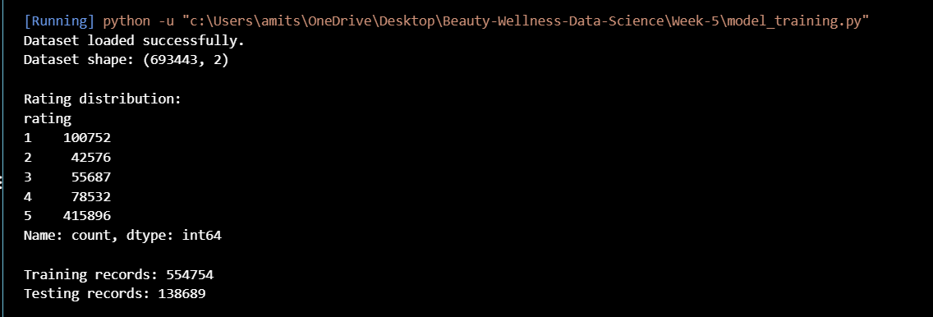
Figure 1. Dataset size and stratified train/test split from the supplied execution screenshot.

4. Text Representation with TF-IDF

Why raw text needs conversion
Most conventional scikit-learn classifiers require numerical input rather than raw sentences. TF-IDF (term frequency–inverse document frequency) converts review text into a sparse numerical representation. It gives weight to terms based on how often they occur within a review and how informative they are across the collection. The resulting features allow a classifier to learn associations between words or short phrases and rating labels.

Configuration used
Each model pipeline contains a `TfidfVectorizer` with `max_features=20000`, `ngram_range=(1, 2)`, `min_df=2`, and English stop-word removal. The maximum feature setting limits the vocabulary to at most 20,000 features. Unigrams represent individual tokens, while bigrams represent two-token sequences and can preserve simple phrases such as “not good.” `min_df=2` excludes terms appearing in only one document. Stop-word removal reduces some very common English words, although any preprocessing choice can also remove words that matter in particular contexts.

Why the vectorizer is inside the pipeline
The script places TF-IDF and the classifier in the same scikit-learn Pipeline. This is an important design choice: during `fit`, the vectorizer learns vocabulary and inverse-document-frequency values from the training data only. The test text is transformed using the already-fitted vectorizer during prediction. Fitting a vectorizer on all data before the split would allow information about the test distribution to influence feature preparation, creating a form of data leakage.

Limitations of bag-of-words features
TF-IDF does not fully understand meaning, sarcasm, context, or product-specific knowledge. It can treat phrases with similar words as similar even when the intended meaning differs. English stop-word removal may be unsuitable for multilingual reviews, and tokenization may not capture every spelling variation or emoji. More advanced embeddings or transformer models could be explored later, but they would require additional compute, careful evaluation, and a fair comparison against the baseline results reported here.

5. Model 1 — Multinomial Naive Bayes

Model overview
Multinomial Naive Bayes is a probabilistic classifier based on Bayes’ theorem and a simplifying conditional-independence assumption between features given a class. In text classification, it is commonly used with word-count or TF-IDF representations. The model estimates how strongly the observed text features are associated with each rating class and selects the class with the highest estimated posterior probability.

Implementation in this project
The uploaded script places `MultinomialNB()` after the TF-IDF vectorizer in a Pipeline. The vectorizer is configured identically to the Logistic Regression pipeline, allowing the comparison to focus mainly on the classifier choice rather than giving one model a different text representation. The model is fitted on `X_train` and `y_train`, then predicts ratings for `X_test`.

Observed performance
The reported accuracy is 0.707655, or approximately 70.77%. Macro precision is 0.520400, macro recall is 0.378670, and macro F1-score is 0.372669. The difference between accuracy and macro F1-score indicates that performance is not uniform across rating classes. Macro metrics calculate a score for each class and average the class scores equally, which gives minority ratings a stronger influence than they receive in ordinary accuracy.

Strengths and limitations
Naive Bayes is relatively fast and provides a useful baseline for large sparse text data. Its conditional-independence assumption is simplistic: real review words are related, and phrases may carry meaning that independent token evidence cannot fully represent. The model’s lower macro recall and macro F1-score in this run suggest that its performance across all five ratings is weaker than the alternative model. It remains useful as a benchmark and should not be discarded from the comparison simply because it did not win.

6. Model 2 — Logistic Regression

Model overview
Logistic Regression is a supervised linear classification algorithm. For multiple rating categories, the classifier estimates class scores from the weighted TF-IDF features and converts them into class probabilities. The predicted label is the class with the strongest score or probability. Despite the word “regression” in its name, Logistic Regression is widely used for classification tasks.

Implementation in this project
The script creates a Pipeline with the same TF-IDF settings as the Naive Bayes pipeline, followed by `LogisticRegression(max_iter=300, random_state=42)`. The model is trained on the training partition and evaluated on the held-out test partition. The script records the four selected metrics and retains the model if its macro F1-score exceeds the best score observed so far.

Observed performance
Logistic Regression achieved accuracy 0.726518, macro precision 0.511134, macro recall 0.437938, and macro F1-score 0.441833. It has higher accuracy, macro recall, and macro F1-score than Multinomial Naive Bayes in this run. Its macro precision is slightly lower, which means that the best model does not outperform the baseline on every metric. The selection rule in the script explicitly prioritizes macro F1-score, not accuracy or precision alone.

Convergence warning
The console reports that Logistic Regression reached the configured maximum of 300 iterations before the optimizer declared convergence. The script still completed and saved outputs, but the warning means optimization may not have fully stabilized under the current settings. Possible next steps include increasing `max_iter`, examining solver choices, and reviewing convergence after a controlled rerun. Any revised metrics should be reported only after the updated model is trained and evaluated again.

7. Evaluation Metrics and Model Comparison

Accuracy
Accuracy is the fraction of all test examples whose predicted rating equals the true rating. Logistic Regression scored 0.726518 (about 72.65%), while Multinomial Naive Bayes scored 0.707655 (about 70.77%). Accuracy is intuitive, but in an imbalanced five-class dataset it can hide poor performance on the less common rating categories.

Macro precision
Macro precision calculates precision separately for each class and then takes the unweighted mean. The reported values are 0.520400 for Naive Bayes and 0.511134 for Logistic Regression. Naive Bayes has the slightly higher macro precision in this run. Precision answers, for each class, how often predictions of that class are correct; a macro average gives each rating equal weight regardless of how many test examples it contains.

Macro recall
Macro recall is the unweighted mean of class-level recall values. It measures how well the model identifies examples belonging to each true class. Logistic Regression achieved 0.437938 compared with 0.378670 for Naive Bayes. This suggests better average class coverage for Logistic Regression, though the score also shows substantial room for improvement.

Macro F1-score and selection rule
Macro F1-score is the unweighted average of the F1-score for each class, where F1 combines precision and recall. Naive Bayes scored 0.372669, while Logistic Regression scored 0.441833. The script selects the model with the higher macro F1-score, so Logistic Regression becomes the saved best model. This is a reasonable criterion when the project wants to avoid evaluating performance only through the dominant five-star class.

Comparison summary
The comparison does not show that Logistic Regression is universally superior. It is the best model according to the selected macro F1 criterion on this test split. Naive Bayes has slightly higher macro precision, and the Logistic Regression convergence warning should be addressed before treating the result as final. Any future model should be compared on the same split and metrics, with the same validation discipline.
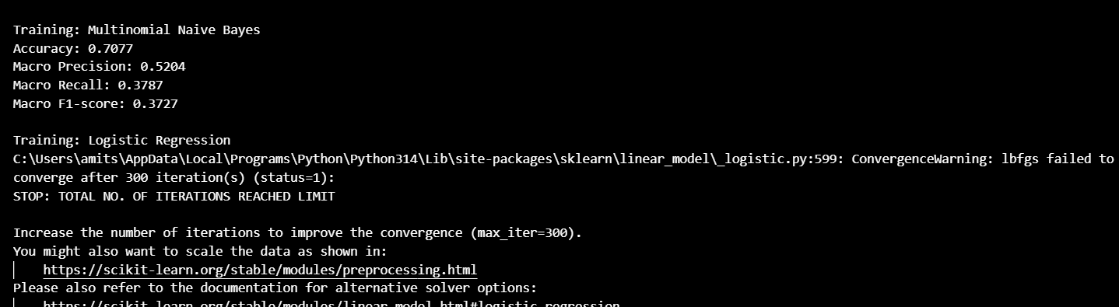
Figure 2. Model comparison results from the supplied terminal screenshot.

8. Confusion Matrix and Error Analysis

What the matrix represents
A confusion matrix compares actual rating labels with predicted rating labels. In the supplied image, rows represent true labels and columns represent predicted labels from 1 through 5. Values on the diagonal are correct predictions; off-diagonal values show where the classifier confuses one rating with another. The image title identifies Logistic Regression as the selected model.

Matrix totals and validation
The displayed matrix rows sum to 20,151 for true rating 1; 8,515 for true rating 2; 11,137 for true rating 3; 15,707 for true rating 4; and 83,179 for true rating 5. Together these totals equal 138,689, which matches the reported test-set size. This confirms that the screenshot matrix is consistent with the current run’s 138,689 test records. The older draft report’s 13,869 figure was a stale value and should not be retained.

Correct predictions and common confusions
The diagonal counts are 15,558 for rating 1, 679 for rating 2, 2,494 for rating 3, 2,474 for rating 4, and 79,555 for rating 5. The largest correct-prediction count is for rating 5, which also has by far the most examples. The matrix shows substantial cross-class confusion, especially where true ratings 2 and 3 are predicted as 1 or 5. True rating 4 is frequently predicted as 5, and true rating 5 is sometimes predicted as 4.

Interpretation caution
Raw matrix counts depend on class frequency. A high count of correct five-star predictions is partly expected because five-star reviews dominate the dataset. To compare class performance fairly, inspect normalized confusion-matrix percentages and per-class precision, recall, and F1 values in the classification report JSON. The matrix should be used to locate error patterns, not as a stand-alone proof of model quality.
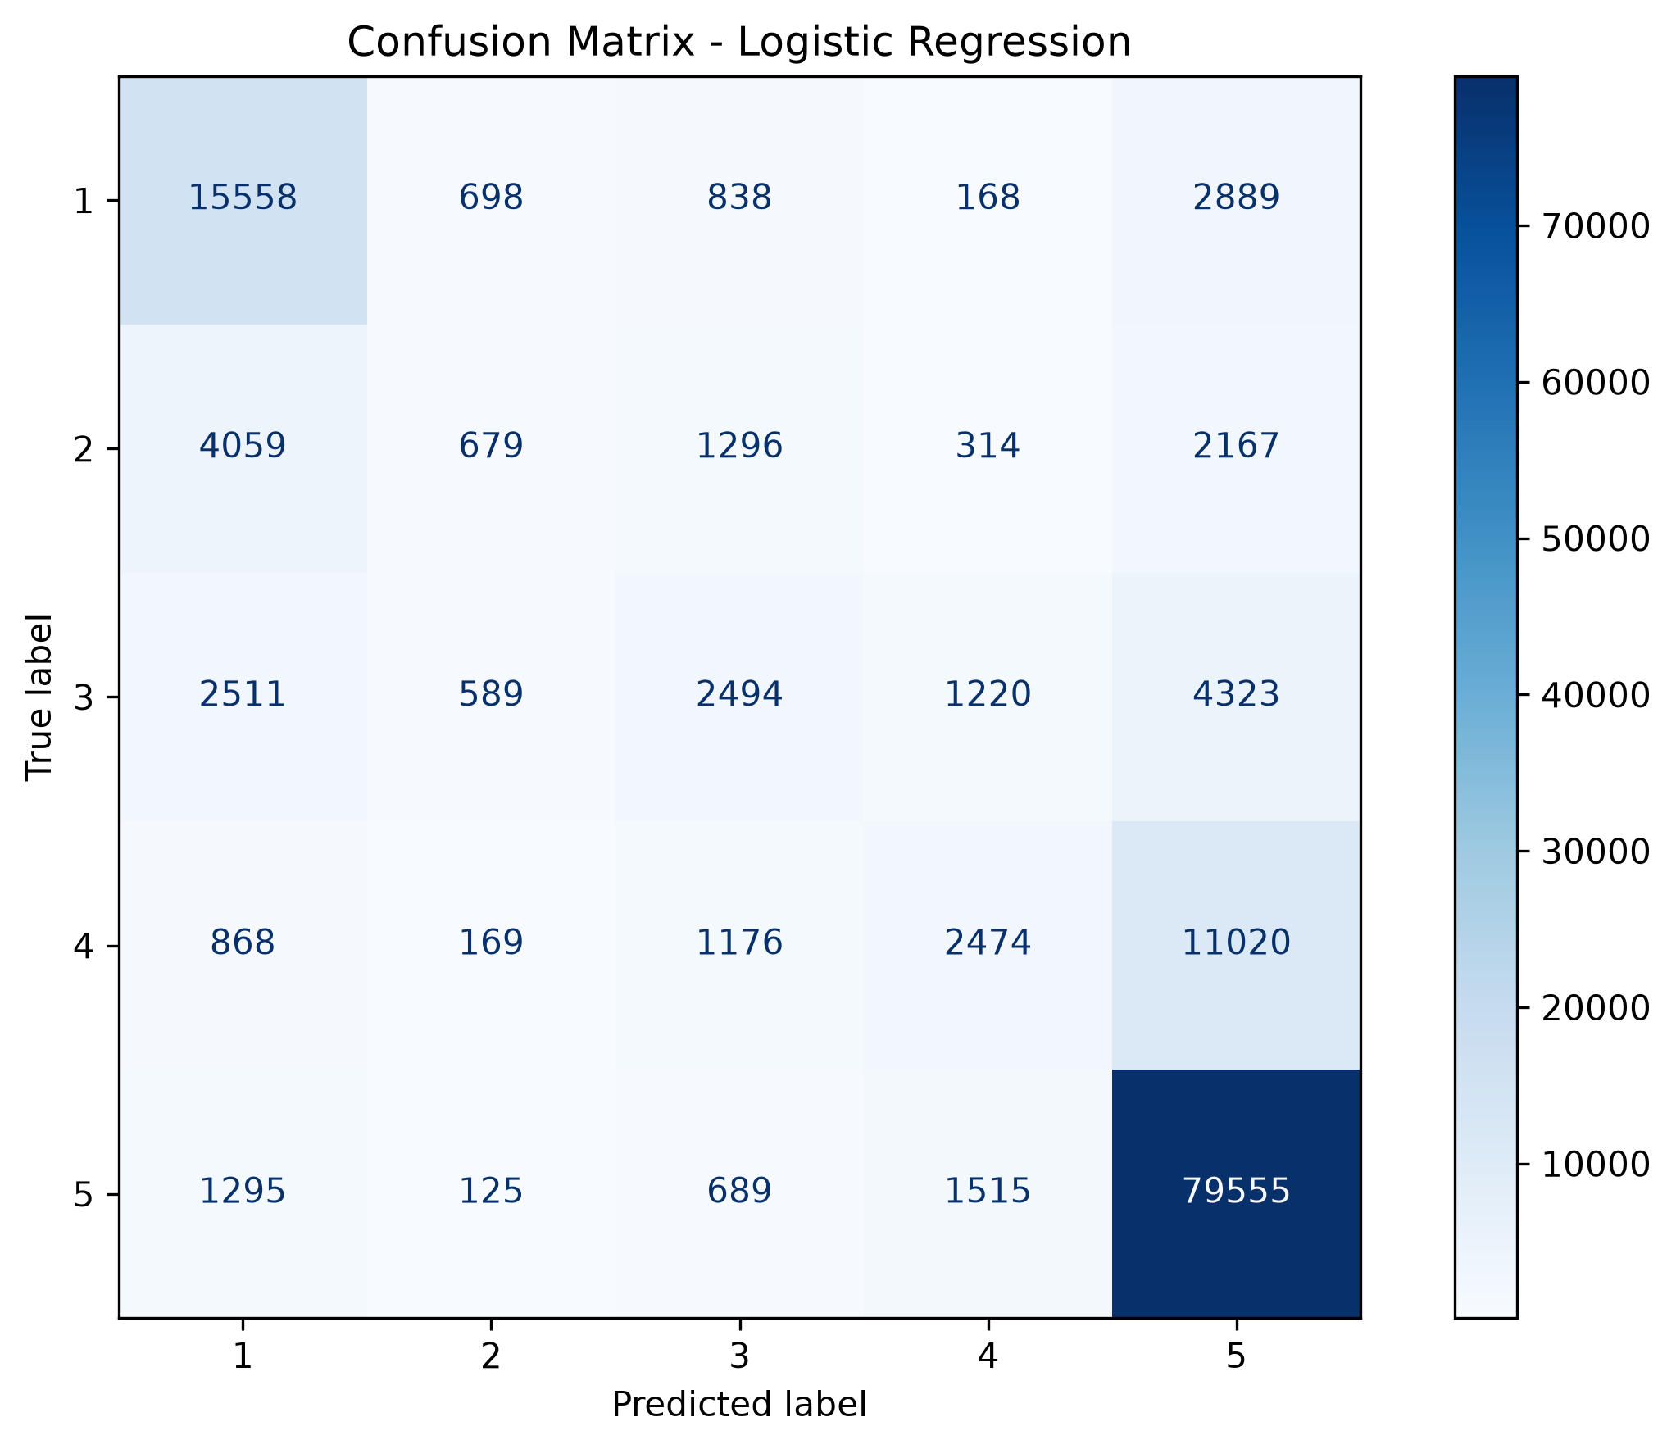
Figure 3. Confusion matrix for Logistic Regression; cell counts sum to 138,689.

9. Outputs, Model Saving, and Reproducibility

Comparison and predictions
The script saves `data/processed/week5_model_comparison.csv`, which contains the model name, accuracy, macro precision, macro recall, and macro F1-score. It also writes `data/processed/week5_test_predictions.csv`, which contains the actual test rating and a prediction column for each trained classifier. The script reloads the saved predictions CSV and prints the shapes as a basic check that the file was written and can be read.

Classification reports
For each model, the script creates a detailed classification report with per-class precision, recall, F1-score, and support. The reports are saved as JSON files under `data/processed/`: one for Multinomial Naive Bayes and one for Logistic Regression. These JSON files provide a more detailed view than the aggregate comparison table and should be consulted when explaining which ratings are easiest or hardest to predict.

Saved best model
The selected pipeline is saved to `models/week5_best_model.joblib`. Because the vectorizer is part of the pipeline, the saved artifact contains both the fitted text transformation and classifier. It can be loaded later with joblib and used to predict ratings for new review text, provided that compatible Python and library versions are available. Serialized models should only be loaded from trusted sources.

Visualization and evidence
The confusion matrix is saved as `visuals/week5_confusion_matrix.png`. The supplied screenshots show dataset splitting, model comparison, the confusion matrix, output locations, and successful completion. Keep these screenshots in `Week-5/screenshots/` if the internship portal requires execution evidence. The README and report should refer to the same file paths used by the script.

Repeatability
The script fixes `random_state=42` for the train-test split and Logistic Regression. Repeatability also depends on the input CSV, library versions, and code version. To make the result reproducible, preserve the script, input dataset version, package versions, output files, and execution evidence together. If the cleaned dataset changes, the train/test split and metrics may change as well.
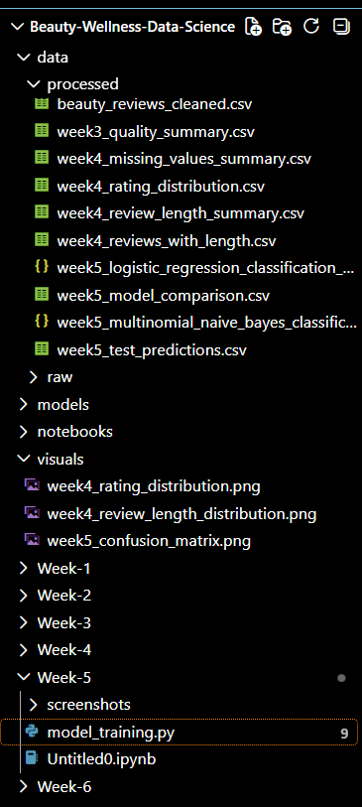
Figure 4. Saved project outputs shown in the supplied file explorer screenshot.
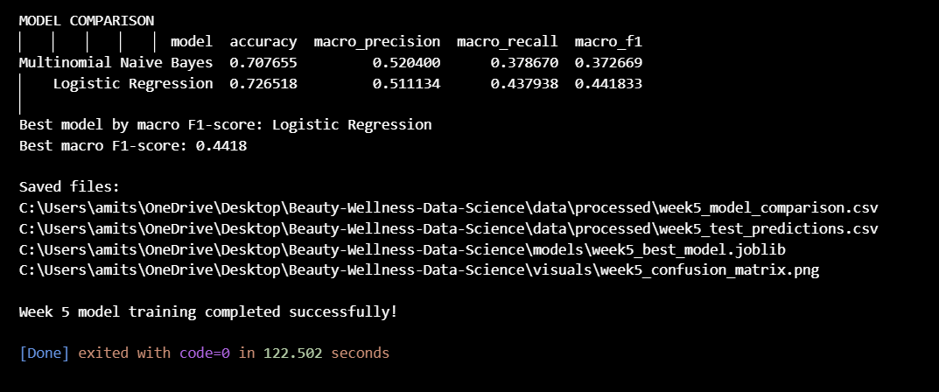
Figure 5. Successful completion and final model comparison shown in the terminal.

10. Limitations, Risks, and Improvement Plan

Class imbalance
The dataset has 415,896 five-star records compared with 42,576 two-star records. This imbalance can bias a classifier toward the majority class. Macro metrics reduce the dominance of the majority class in the summary score, but they do not automatically correct the model’s learning behaviour. Later experiments could evaluate class weighting or resampling within a properly designed training workflow, while keeping the test set untouched.

Model quality
The best macro F1-score is 0.441833, indicating that performance across all five classes remains limited. The model should be treated as a baseline rather than a production-ready rating predictor. Misclassifying adjacent ratings may be less severe than confusing one-star and five-star reviews, but the current metrics treat each incorrect class prediction as an error. A future analysis could explicitly examine ordinal-rating error or mean absolute rating error, provided those metrics are defined and computed correctly.

Convergence and hyperparameters
The Logistic Regression convergence warning should be documented. Increasing the iteration limit may help the solver converge, but it should not be done only to improve the appearance of the output. The revised model must be trained again and evaluated using the same held-out protocol. Hyperparameter tuning should use training-only validation or cross-validation, not repeated experimentation against the test set.

Feature limitations
TF-IDF uses lexical patterns rather than deep semantic understanding. It may struggle with sarcasm, mixed sentiment, negation, misspellings, product-specific names, and multilingual text. Stop-word removal can sometimes remove words that matter in a phrase. Future improvements could test alternative vectorizer settings, character n-grams, class weights, or a pretrained text model, but each change should be measured rather than assumed to be better.

Responsible use
The model predicts labels present in the dataset and may reproduce dataset biases. It should not be used as the sole basis for consequential decisions about customers, products, sellers, or review authenticity. Aggregate analysis and clear reporting are appropriate for this internship task. User identifiers are not needed for the current model and should not be exposed unnecessarily in public outputs.

11. Conclusion and Submission Checklist

Conclusion
Week 5 completed a model-training and evaluation workflow for predicting customer ratings from review text. The script prepared a two-column modelling dataset, created a stratified 80/20 split, trained Multinomial Naive Bayes and Logistic Regression pipelines with TF-IDF features, evaluated both models, saved detailed reports and predictions, selected a best model by macro F1-score, and generated a confusion matrix. Logistic Regression was selected with macro F1-score 0.441833 and accuracy 0.726518.

Main findings
The results show that Logistic Regression outperformed Multinomial Naive Bayes on accuracy, macro recall, and macro F1-score, while Naive Bayes had slightly higher macro precision. The class distribution is imbalanced, and the confusion matrix shows that some rating categories remain difficult to distinguish. The Logistic Regression convergence warning is a meaningful technical note and should be retained in the submission rather than ignored.

Final checklist
Before submission, rerun the script on the intended cleaned CSV; confirm the data shape is 693,443 × 2; verify the train/test counts total 693,443; check the comparison CSV against the console; confirm that the confusion matrix sums to 138,689; open both classification report JSON files; verify the model artifact and prediction CSV exist; and ensure the report, README, and screenshots describe the same run. If the model is rerun after changing settings, regenerate all dependent outputs and update the reported metrics.

Closing statement
This phase establishes a reproducible baseline for rating prediction and prepares saved artifacts for further experimentation. Future work should focus on class-wise error analysis, resolving convergence through a controlled rerun, and evaluating improvements without leaking information from the test set. The reported figures describe this specific run and should not be generalized beyond the dataset and evaluation setup used here.

